Clean Code Principles - Avoid Hardcoding
# Source: AI Source: Provided by: [Data Path: Persons Table -> ID Column: 1, Name_En Column: Motasem Essam] -> From: [Chatgpt (GPT‑5 Mini)] on [12/9/2025]
Hardcoding means placing fixed values directly in the code instead of using constants, variables, or configuration.
👉 Hardcoded values make code harder to maintain, reuse, and update.

🔑 Why It Matters
# Source: AI Source: Provided by: [Data Path: Persons Table -> ID Column: 1, Name_En Column: Motasem Essam] -> From: [Chatgpt (GPT‑5 Mini)] on [12/9/2025]
- Makes code flexible and reusable
- Easier to update values in one place
- Improves readability and clarity
- Reduces risk of errors when requirements change

❌ Bad Example (Hardcoded Values)
# Source: AI Source: Provided by: [Data Path: Persons Table -> ID Column: 1, Name_En Column: Motasem Essam] -> From: [Chatgpt (GPT‑5 Mini)] on [12/9/2025]
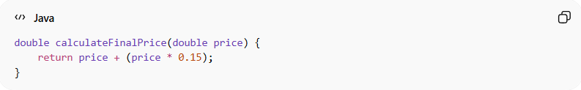
double calculateFinalPrice(double price) {
return price + (price * 0.15);
}
👉 Problems:
- 0.15 is a magic number
- No explanation of what it represents
- Hard to change later

✅ Good Example (Using Constant)
# Source: AI Source: Provided by: [Data Path: Persons Table -> ID Column: 1, Name_En Column: Motasem Essam] -> From: [Chatgpt (GPT‑5 Mini)] on [12/9/2025]
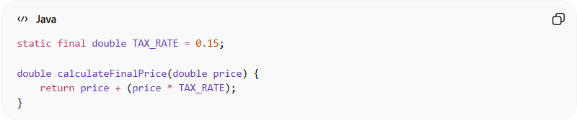
static final double TAX_RATE = 0.15;

double calculateFinalPrice(double price) {
return price + (price * TAX_RATE);
}
👉 Benefits:
- Clear meaning (TAX_RATE)
- Easy to update in one place

❌ Another Bad Example
# Source: AI Source: Provided by: [Data Path: Persons Table -> ID Column: 1, Name_En Column: Motasem Essam] -> From: [Chatgpt (GPT‑5 Mini)] on [12/9/2025]
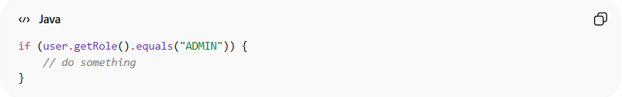
if (user.getRole().equals("ADMIN")) {
// do something
}
👉 Problem:
- "ADMIN" is hardcoded
- Risk of typos and inconsistency

✅ Good Example (Using Constant or Enum)
# Source: AI Source: Provided by: [Data Path: Persons Table -> ID Column: 1, Name_En Column: Motasem Essam] -> From: [Chatgpt (GPT‑5 Mini)] on [12/9/2025]
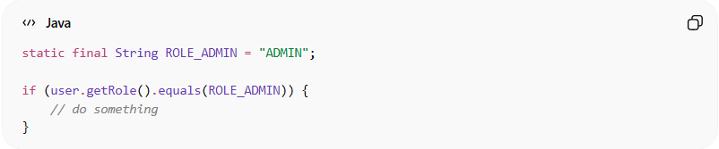
static final String ROLE_ADMIN = "ADMIN";

if (user.getRole().equals(ROLE_ADMIN)) {
// do something
}
OR better:
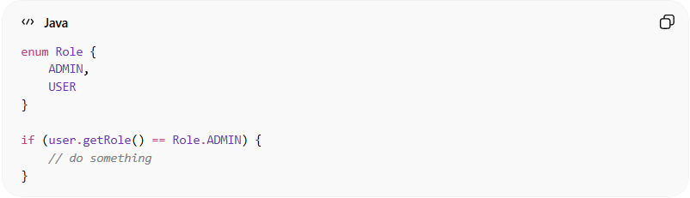
enum Role {
ADMIN,
USER
}

if (user.getRole() == Role.ADMIN) {
// do something
}

❌ Another Bad Example (Hardcoded Config)
# Source: AI Source: Provided by: [Data Path: Persons Table -> ID Column: 1, Name_En Column: Motasem Essam] -> From: [Chatgpt (GPT‑5 Mini)] on [12/9/2025]
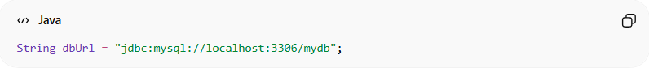
String dbUrl = "jdbc:mysql://localhost:3306/mydb";

✅ Good Example (Configuration)
# Source: AI Source: Provided by: [Data Path: Persons Table -> ID Column: 1, Name_En Column: Motasem Essam] -> From: [Chatgpt (GPT‑5 Mini)] on [12/9/2025]
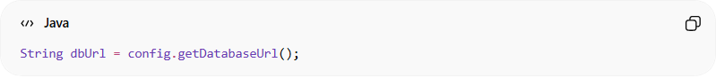
String dbUrl = config.getDatabaseUrl();
👉 Value comes from configuration (file, environment, etc.)

💡 Key Idea
# Source: AI Source: Provided by: [Data Path: Persons Table -> ID Column: 1, Name_En Column: Motasem Essam] -> From: [Chatgpt (GPT‑5 Mini)] on [12/9/2025]
Replace magic values with named constants or configurations to make your code clear and flexible.

🚫 Common Mistakes
# Source: AI Source: Provided by: [Data Path: Persons Table -> ID Column: 1, Name_En Column: Motasem Essam] -> From: [Chatgpt (GPT‑5 Mini)] on [12/9/2025]
- Magic numbers (0.1, 100, 999)
- Hardcoded strings ("ADMIN", "ERROR")
- Fixed URLs, paths, or credentials
- Repeating the same value in multiple places

🧾 Summary
# Source: AI Source: Provided by: [Data Path: Persons Table -> ID Column: 1, Name_En Column: Motasem Essam] -> From: [Chatgpt (GPT‑5 Mini)] on [12/9/2025]
Avoiding hardcoding helps you:
- Write flexible and maintainable code
- Improve readability
- Reduce duplication and errors
- Make updates easier and safer

